Edited Book Template

Title of the book:
Type of book: Edited/Authored

Editors/Authors: Editors Name, Editors Name, Editors Name,
Affiliations: Affiliation, Affiliation, Affiliation

All Editors and Authors Email ID (Mandatory): abc@gmail.com, pqrs@gmail.com, xyz@gmail.com

All Editors and Authors ORCID IDs (Mandatory): https://orcid.org/0000-, https://orcid.org/0000-0-, https://orcid.org/0000-0

Published, marketed, and distributed by:

Red Flower Publications
48/41-42, DSIDC, Pocket-II Mayur Vihar Phase-I
Delhi - 110 091 (India)

Phone: +91-8130750089, +91-11-79695648
E-Mail: books@rfppl.co.in
Website: www.rfppl.co.in

ISBN:
E-ISBN:
http://dx.doi.org/10.21088
Copyright © Authors Name, 2025.

Citation: Surname, N. L., Surname, S. K., Surname, O., & Surname, J. (Eds.). (2025). Book title. Red Flower Publications.

This book is published online under a fully open access program and is licensed under a Creative Commons Attribution-Non-commercial 4.0 International License (CC BY-NC 4.0). This open access license allows third parties to copy and redistribute the material in any medium or format, provided that proper attribution is given to the author(s) and the published source. The publishers, authors, and editors are not responsible for errors or omissions, or for any consequences arising from the application of the information presented in this book, and make no warranty, express or implied, regarding the content of this publication. Although the publisher, authors, and editors have made every effort to ensure that the content is not misleading or false, they do not represent or warrant that the information-particularly regarding verification by third parties-has been verified. The publisher is neutral with regard to jurisdictional claims in published maps and institutional affiliations. The authors and publishers have made every effort to contact all copyright holders of the material reproduced in this publication and apologize to anyone we may have been unable to reach. If any copyright material has not been acknowledged, please write to us so we can correct it in a future reprint.
Preface
This book offers a comprehensive exploration of the evolving landscape of machine learning (ML) and deep learning (DL). It begins with a detailed overview of modern architectures and trends in Chapters 1-3, ………..
Author Name
Author Name
Author Name

Table of Contents

Please note: You do not need to prepare the table of contents. It will be handled by our team during the copy-editing stage

Chapter 1: Artificial Intelligence

First Author ¹, Second Author ², Third Author ³
¹ Department, University, State, Country. (Size 9 &italic)
² Department, University, State, Country.
³ Department, University, State, Country.

Abstract (Optional but good for indexing): (Size 10) Kindly read the guidelines provided at the end of this document.

Keywords: (Size 10) 5-6 keywords.

1 Introduction
The (Size 11)

Chapter 2: Kindly read the guidelines provided at the end of this document
First Author ¹, Second Author ², Third Author ³
¹ Department, University, State, Country. (Size 9 &italic)
² Department, University, State, Country.
³ Department, University, State, Country.

Abstract (Optional but good for indexing): (Size 10) Kindly read the guidelines provided at the end of this document.
Keywords: (Size 10) 5-6 keywords.
1 Introduction
The (Size 11)

Chapter 3: Test: You must use the styles given in the Home menu to keep the formatting consistent
First Author ¹, Second Author ², Third Author ³
¹ Department, University, State, Country. (Size 9 &italic)
² Department, University, State, Country.
³ Department, University, State, Country.

Abstract (Optional but good for indexing): (Size 10) Kindly read the guidelines provided at the end of this document.
Keywords: (Size 10) 5-6 keywords.
1 Introduction
The (Size 11)

Chapter 4: You must use the styles given in the Home menu to keep the formatting consistent
First Author ¹, Second Author ², Third Author ³
¹ Department, University, State, Country. (Size 9 &italic)
² Department, University, State, Country.
³ Department, University, State, Country.

Abstract (Optional but good for indexing): (Size 10) Kindly read the guidelines provided at the end of this document.
Keywords: (Size 10) 5-6 keywords.
1 Introduction
The (Size 11)

Chapter 5: You must use the styles given in the Home menu to keep the formatting consistent
First Author ¹, Second Author ², Third Author ³
¹ Department, University, State, Country. (Size 9 &italic)
² Department, University, State, Country.
³ Department, University, State, Country.

Abstract (Optional but good for indexing): (Size 10) Kindly read the guidelines provided at the end of this document.
Keywords: (Size 10) 5-6 keywords.
1 Introduction
The (Size 11)

Chapter 6: Test test
First Author ¹, Second Author ², Third Author ³
¹ Department, University, State, Country. (Size 9 &italic)
² Department, University, State, Country.
³ Department, University, State, Country.

Abstract (Optional but good for indexing): (Size 10) Kindly read the guidelines provided at the end of this document.
Keywords: (Size 10) 5-6 keywords.
1 Introduction
The (Size 11)

Chapter 7: Test test
First Author ¹, Second Author ², Third Author ³
¹ Department, University, State, Country. (Size 9 &italic)
² Department, University, State, Country.
³ Department, University, State, Country.

Abstract (Optional but good for indexing): (Size 10) Kindly read the guidelines provided at the end of this document.
Keywords: (Size 10) 5-6 keywords.
1 Introduction
The (Size 11)

Chapter 8: Test test
First Author ¹, Second Author ², Third Author ³
¹ Department, University, State, Country. (Size 9 &italic)
² Department, University, State, Country.
³ Department, University, State, Country.

Abstract (Optional but good for indexing): (Size 10) Kindly read the guidelines provided at the end of this document.
Keywords: (Size 10) 5-6 keywords.
1 Introduction
The (Size 11)

Chapter 9: Test test
First Author ¹, Second Author ², Third Author ³
¹ Department, University, State, Country. (Size 9 &italic)
² Department, University, State, Country.
³ Department, University, State, Country.

Abstract (Optional but good for indexing): (Size 10) Kindly read the guidelines provided at the end of this document.
Keywords: (Size 10) 5-6 keywords.
1 Introduction
The (Size 11)

Chapter 10: Test test
First Author ¹, Second Author ², Third Author ³
¹ Department, University, State, Country. (Size 9 &italic)
² Department, University, State, Country.
³ Department, University, State, Country.

Abstract (Optional but good for indexing): (Size 10) Kindly read the guidelines provided at the end of this document.
Keywords: (Size 10) 5-6 keywords.
1 Introduction
The (Size 11)

Chapter 11: Test test
First Author ¹, Second Author ², Third Author ³
¹ Department, University, State, Country. (Size 9 &italic)
² Department, University, State, Country.
³ Department, University, State, Country.

Abstract (Optional but good for indexing): (Size 10) Kindly read the guidelines provided at the end of this document.
Keywords: (Size 10) 5-6 keywords.
1 Introduction
The (Size 11)

Chapter 12: Test test
First Author ¹, Second Author ², Third Author ³
¹ Department, University, State, Country. (Size 9 &italic)
² Department, University, State, Country.
³ Department, University, State, Country.

Abstract (Optional but good for indexing): (Size 10) Kindly read the guidelines provided at the end of this document.
Keywords: (Size 10) 5-6 keywords.
1 Introduction
The (Size 11)

Chapter 13: Test test
First Author ¹, Second Author ², Third Author ³
¹ Department, University, State, Country. (Size 9 &italic)
² Department, University, State, Country.
³ Department, University, State, Country.

Abstract (Optional but good for indexing): (Size 10) Kindly read the guidelines provided at the end of this document.
Keywords: (Size 10) 5-6 keywords.
1 Introduction
The (Size 11)

Chapter 14: Test test
First Author ¹, Second Author ², Third Author ³
¹ Department, University, State, Country. (Size 9 &italic)
² Department, University, State, Country.
³ Department, University, State, Country.

Abstract (Optional but good for indexing): (Size 10) Kindly read the guidelines provided at the end of this document.
Keywords: (Size 10) 5-6 keywords.
1 Introduction
The (Size 11)

Chapter 15: Template Formatting Guidelines
First Author ¹, Second Author ², Third Author ³
¹ Department, University, State, Country. (Size 9 &italic)
² Department, University, State, Country.
³ Department, University, State, Country.

Abstract (Optional but good for indexing): (Size 10) The pages size should be set to ISO B5, measuring 176 mm X 250 mm, with margins: Top, Left, Right: 20mm, Bottom: 25mm. Use Times New Roman font with spacing 1.15 throughout the manuscript for consistency and readability. Ensure all the figures and tables cited in the paragraphs. Ensure all the citations listed in the references section. Use Vancouver citation style for both in-text citations and the reference list (Frog RR, Frog BB. I've got ninety-nine problems but a fly ain't one. J Eso Ridic [internet]. 1999 Mar [cited 2008 Feb 2]; 33(1):12-20. Available from: http://frogscholars.ca/books/flygourmand/articles/flyfood1=12345). For more guidance, refer to the citation and reference style of this paper: https://dal.ca.libguides.com/CitationStyleGuide/Vancouver

Keywords: (Size 10) 5-6 keywords arranged alphabetically and separated by commas.
1 Introduction
The pages size should be set to ISO B5, measuring 176 mm X 250 mm, with margins: Top, Left, Right: 20mm, Bottom: 25mm. Ensure all the figures and tables cited in the paragraphs. Ensure all the citations listed in the references section. Use Times New Roman of size 11 and spacing 1.15 for text. Use Vancouver citation style for both in-text citations and the reference list. For more guidance, refer to the citation and reference style of this paper: https://dal.ca.libguides.com/CitationStyleGuide/Vancouver
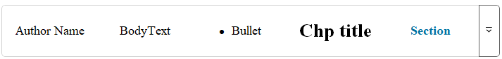
Fig. 1.1 Use styles for QUICK formatting Chapter title, Authors Name, Sections, Sub-section, and Body Text
2 Literature review
Fig. 1.1 shows the co-occurrence analysis of the trending keywords in ML. Table 1.1 shows the key architectural innovations and enhancements in ML and DL. Ensure that all tables and figures are properly cited within the text.
3 Methods and materials
Fig. 1.1 shows the co-occurrence analysis of the trending keywords in ML. Table 1.1 shows the key architectural innovations and enhancements in ML and DL.
4 Results and discussions
Fig. 1.1 shows the use of styles created for formatting your book Table 1.1 shows the key architectural innovations and enhancements in ML and DL.
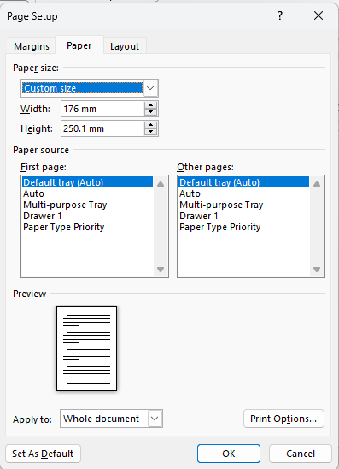
Fig. 1.2 Page size
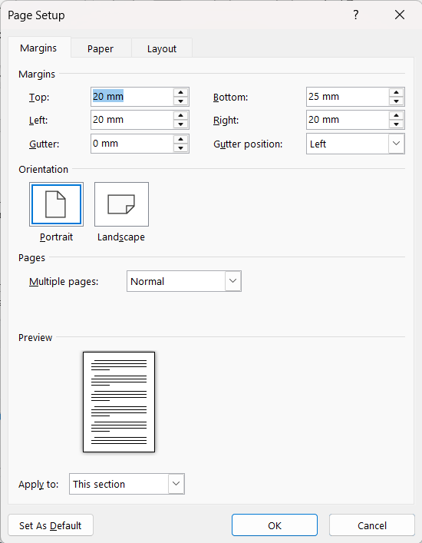
Fig. 1.3 Page margin
Table 1.1 Key architectural innovations and enhancements in ML and DL. Text within tables should be set in size 10.
Sr. No. | References | Architectural Innovation | Description | Enhancements | Key Applications
1 | (Shrestha & Mahmood, 2019; Aziz et al., 2020; Deng, 2014) | Convolutional Neural Networks (CNNs) | A category of deep neural networks predominantly employed for scrutinizing visual stimuli. | Noteworthy advancements encompass. | Disciplines of interest encompass.
2 | (Alzubaidi et al., 2021; Janiesch et al., 2021; Wu & Xie, 2022) | Recurrent Neural Networks (RNNs) | Neural network architectures characterized | Distinctive enhancements embrace proficient handling of sequential datasets. | Application domains.

Conclusions
Transformer-based models such as BERT have caused a significant change in the field of NLP and consistently establish higher levels of performance. These models use self-attention mechanisms to better capture contextual information compared to traditional RNNs and CNNs.
References
- Loth SR, Iscan MY. Morphological age estimation. In: Siegel JA, Knupfer G, editors. Encyclopedia of Forensic Sciences. London: Academic Press; 2010.
- Pickering RB, Bachman D. The use of forensic anthropology. 2009. p.1.
- Scheuer L, Black S. Developmental Juvenile Osteology. San Diego: Elsevier Academic Press; 2000. p. 251.
- Scheuer L, Black S. Developmental Juvenile Osteology. San Diego: Elsevier Academic Press; 2000. pp. 231-242.
- Aggrawal A. Textbook of Forensic Medicine and Toxicology. 2nd ed. Avichal Publication; 2021. pp. 81-82.
- San Millan M, Rissech C, et al. New approach to age estimation of male and female adult skeletons based on the morphological characteristics of the acetabulum. Int J Legal Med. 2017 Mar;131(2):501-525. doi: 10.1007/s00414-016-1406-4. Epub 2016 Jun 30.

Manuscript Submission Checklist:
- Page size set to 176 mm x 250 mm?
- Margins: Top, Left, Right: 20mm, Bottom: 25mm?
- Are all figures and tables cited within the text?
- Are all citations listed in the reference section?
- Text in Times New Roman, size 11, spacing 1.15?

Need Help with Formatting?
If you have any formatting issues or need personal assistance, please email us at books@rfppl.co.in for support.

